Integration of the dll in a .NetFramework project:

1. Create the .NetFramework project
2. 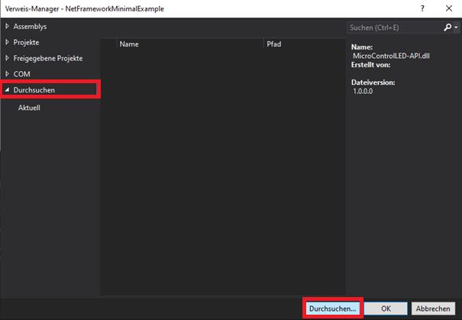Add MicroControlLED-API.dll as reference:

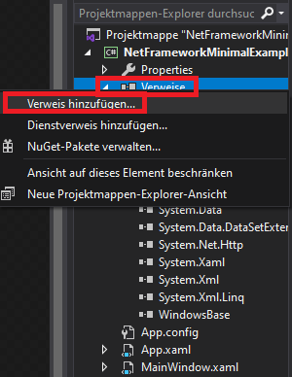

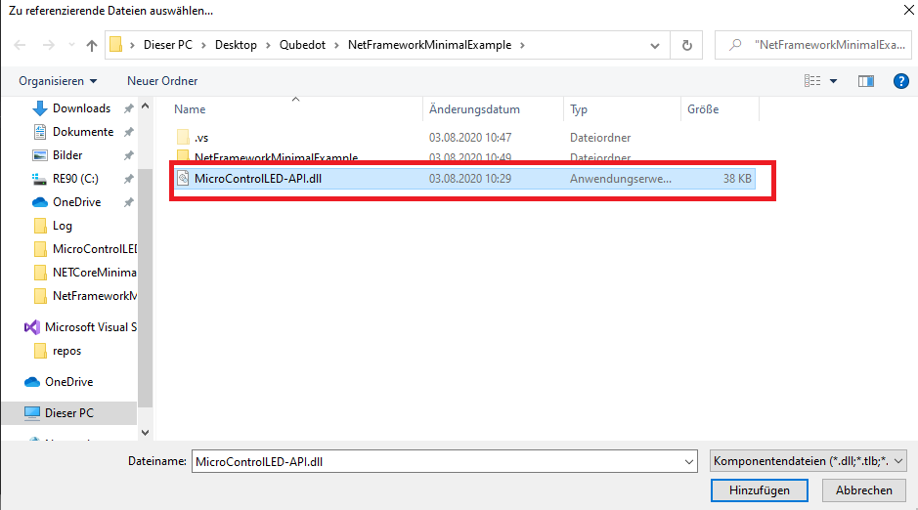

1. Add these libraries to the project:

using System.Collections.Generic;

using MicroControlLED_API.USB_Communication;

Tested with:

.NetFramework 4.7.2

VS 2019

Integration of the dll in a .NetCore project:

1. Create the .NetCore project
2. Add MicroControlLED-API.dll as COM-reference:

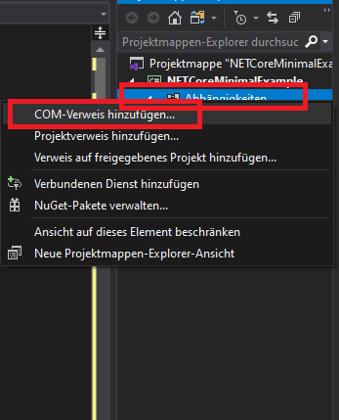



1. Add these libraries to the project:

using System.Collections.Generic;

using MicroControlLED_API.USB_Communication;

1. Install necessary libraries with nuget:

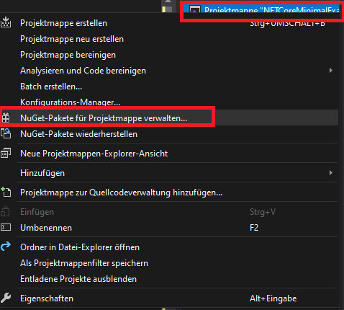

Libraries that are required:

System.Drawing.Common

System.IO

System.IO.Ports

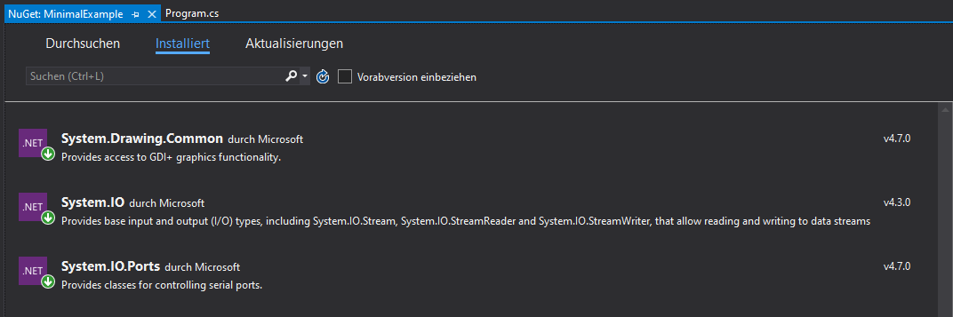

Tested with:

.NetCore 3.1

VS 2019